PuffBOMB
for Xbox Live Arcade

by



Contact
Mike Kasprzak
mk@sykhronics.com
Cell: 519-697-4567
Table of Contents

1. Introduction 3
1.1. Disclaimer 3
2. Gameplay Overview 4
2.1. Bombs 4
2.2. The Vortex 5
3. Classic Mode 6
3.1. How Classic Mode is played 6
3.2. Alternate Solutions 7
3.3. Puzzle Replays 7
3.4. Live High Score System 7
4. Tournament Mode 8
4.1. How Tournament Mode is played 8
4.2. Scoring in Tournament Mode 9
4.3. Dynamic Tournaments 9
5. Xbox Live Achievements 10
6. Additional Content 10
6.1. Sound Packs 10
Appendix A: Classic/Prototype PuffBOMB 11

Introduction

PuffBOMB is a cartoon styled, physics based, puzzle and tournament game involving bombs. The game is based on the freeware puzzle game of the same name.

For more information about the original PuffBOMB, see Appendix A at the end of this document.

Disclaimer

Details are subject to change, as development progresses. Xbox Live features reflect our best understanding of the specifics of the platform as an unlicensed developer.

Gameplay Overview

The game breaks down in to 2 distinct modes. The puzzle mode, also known as “Classic”, and “Tournament” mode.

Bombs
Common to both modes of play are bombs. Bombs are placed relative to a character, and upon detonation, a force is created in the direction between them.
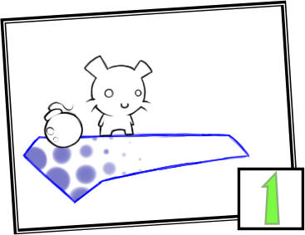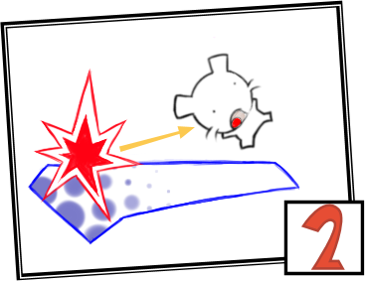

By placing a bomb below the character, they will be shot upward. By placing a bomb to the left of the character, they will be shot to the right.

Depending on the distance between the character and the bomb, the strength of the force varies.

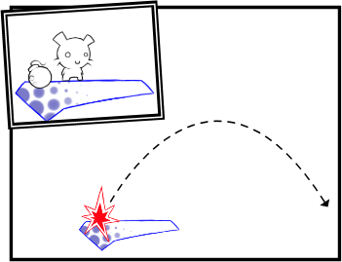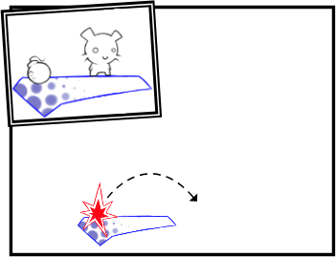

The closer the bomb is to the character, the more powerful the impact. The further away the bomb is, the less powerful the impact.

Both modes are based on the gameplay of the original PuffBOMB game. See Appendix A for more information on the original.

The Vortex
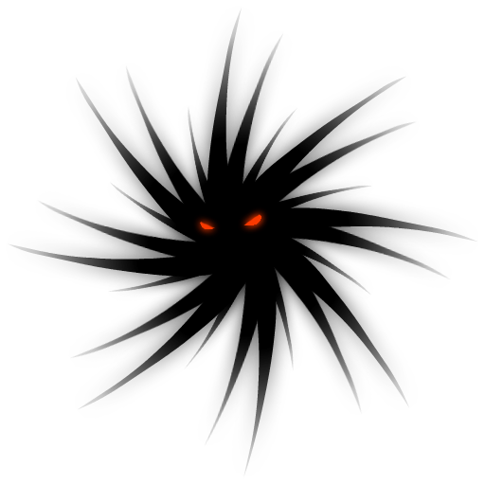
Also found in both modes is the vortex. The vortex represents the end of a level. The goal of all Tournament levels, and most Classic puzzles is to move your character(s) to it.

The vortex has a pull to it. Any objects or debris close to it gets sucked in. At the same time, an object in motion can use the pull of the vortex to slingshot or spin around it to obtain additional pickups.

Classic Mode
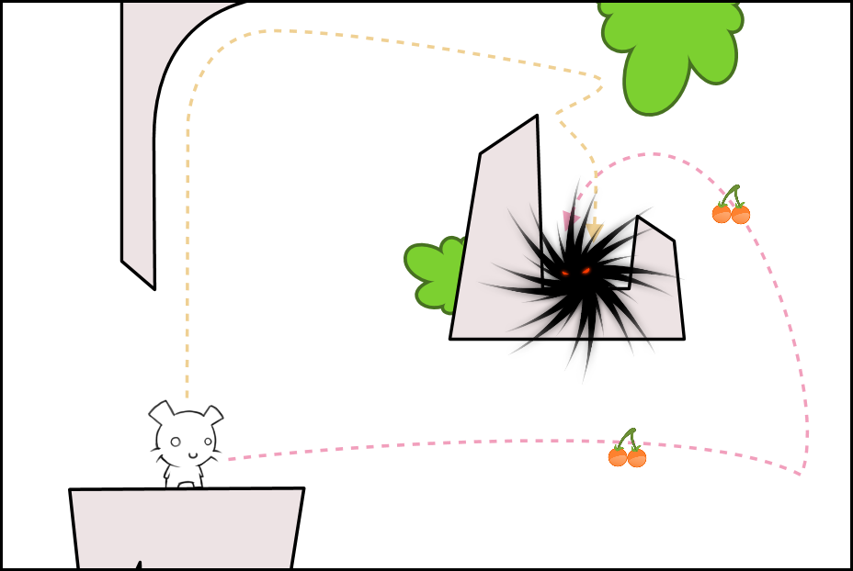
Classic mode, like the original game, is a single-player puzzle game. In it, you are given 1 or more bombs to solve a puzzle with. Each bomb can be given a detonation time, allowing you to chain together multiple explosions.

Between puzzles, you get to pick an available puzzle to solve. Initially, you can pick from the first 3 puzzles. For every puzzle completed, one more puzzle unlocks.

The plan is to include 50 puzzles in Classic Mode.

How Classic Mode is played

At the beginning of a puzzle, you are given the goal for the puzzle. Goals can include moving a single or multiple characters to a vortex, triggering a series of switches or events, or even protecting characters from such scenarios as an avalanche.

Classic Mode itself breaks down in to two modes. Edit mode and Action mode.

In Edit mode, you get to place and modify bombs. You move a cursor around highlighting, selecting, and modifying bombs. Bombs are your tool for solving puzzles. You can use them for either propelling a character, clearing a path, triggering a remote chain of events, or any number of uses.

In Action mode, the game plays out. The camera follows characters or other interesting elements of the puzzle. This continues until the user stops playback, or the puzzle is solved.

Pressing the X button (tentative) toggles between Edit and Action modes. Returning to Edit mode resets the events that occurred in Action mode, allowing you to correct mistakes.

Once a puzzle is solved, you are given the options to continue on to the next level, see a replay, or save a replay for later viewing.

Alternate Solutions

For added replayability, most puzzles in Classic Mode feature alternate solutions. An alternate solution is an alternative goal for the puzzle. Alternate solutions may include picking up items on an alternate route to the goal, using less bombs, or simply reaching a different goal.

Puzzle Replays

Easily, the most requested feature of the original game is replay saving. So at any time during the game, you have the option to save per-puzzle replays. The game will also automatically remember your fastest solution to a puzzle (See Live High Scoring System). Then at a later time, you can play back and edit your favorite or fastest replays.

Live High Score System

For added competition, the solutions to a puzzle can be scored. Scoring works as follows. Each level is given a base score of 2000 points. Every second of time that passes after starting Action Mode lowers the base score by 100, until the puzzle is solved. So if you complete the puzzle in 10.5 seconds, your score for that puzzle will be 950 points (2000 – (10.5 x 100) = 950).

For the global high score table, every score for every puzzle solution is added up (alternate solutions included). Any puzzle you haven't completed are worth 0. The game will automatically save your fastest solution, allowing you to go back and tweak it. Thus, hardcore players can optimize their solutions, to compete for the highest possible score. Or, your score can be used to get a rough idea of how well you're doing compared to your friends.

Tournament Mode
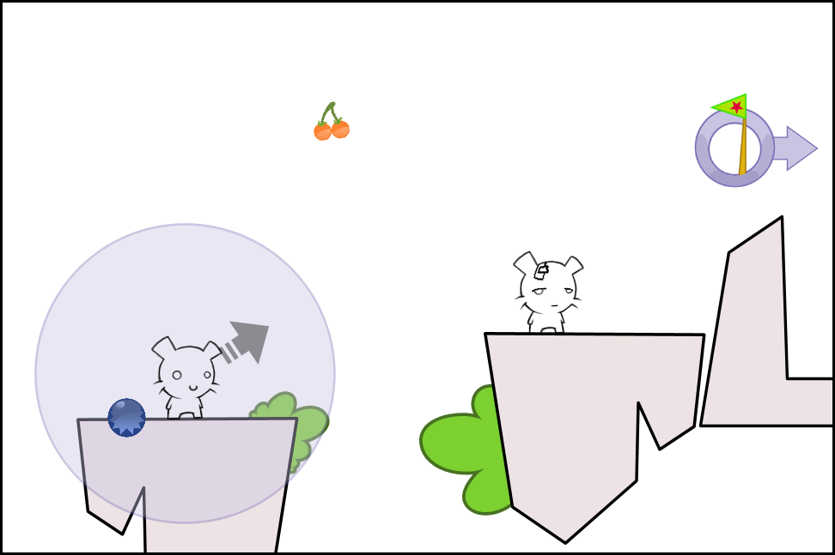

Tournament mode is a 2-4 player multi-player game. Each player takes turns, and is given a single bomb to move their character. It's each players goal to beat the other players by getting the highest score.

The plan is to include 20 levels in Tournament Mode.

How Tournament Mode is played

Each player takes a turn. In a turn, a player is given a single bomb to use. This bomb only affects that players character, and is restricted to placement within a radius of their character. While your bomb can't move other players, you can however hit them with your character.

Unlike Classic Mode, there is no concept of detonation time for bombs. Instead, the bomb explodes almost instantly after the player confirms his choice of position.

The player's character is propelled in the direction between them and the bomb. The game remains active until the player either comes to rest, goes out of bounds, or finishes the level by entering the vortex.

If a player goes out of bounds, an extra shot is counted against them, similar to penalty strokes in golf. They are then placed at the nearest drop point for their next turn.

Unlike golf, players take turns one after other sequentially, without regard for distance from the vortex.

This repeats until all player have either reached the end, or have taken 10 shots.

Scoring in Tournament Mode

A combination of factors determines your score for a level. The primary method of scoring, is by getting your character to the vortex in the least number of shots. The players with the lowest number of shots taken gets 500 points. For every additional shot, the points are reduced by 100. If you can't reach the vortex by the 10th shot, you don't get any points for finishing. For example, if Player 1 gets to the end in 2 shots, and Player 2 gets to the end in 4 shots, then the score thus far is Player 1: 500, Player 2: 300.

The other way to score points is through pickups. Pickups are strategically placed throughout the level, each with values varying from 50-250 points. Thus, getting to the end first isn't always the way to win a level. From the example above, if Player 2 acquired a 250 point pickup in the level, then they would be in the lead, 550 to 500.

At the end of each level, total and per level scores are displayed for each player. At the end of the tournament, the player with the highest score wins.

Dynamic Tournaments

A tournament by default, lasts for 4 levels. At the end of every 4 levels, the players are given the choice to continue for another 4. This continues until they've played all 20 levels.

At the end of a level, players can optionally choose to replay the same level again. This is for the situation where 1 or more players did rather poorly, and as a group they decide it's worth playing the same level again.

Xbox Live Achievements

The following is a tentative list of 12 Xbox Live achievements for the game. Distribution of the 200 gamer score points is to be determined.

Classic
- Complete a third of all classic puzzles
- Complete two thirds of all classic puzzles
- Complete all classic puzzles
- Complete half of all alternate solution
- Complete all alternate solutions

Tournament
- Play and finish a tournament
- Play and finish a 4 player tournament
- Play all 20 tournament levels
- Take less than 10 shots to reach the target on every tournament level
- Play 100 tournaments

Other
- 100 Bombs (Detonate 100 bombs)
- 500 Miles (Approximate total distance traveled)

Additional Content

Throughout development, we'd like to explore several types of download-able content. We're certainly considering your standard fare additional content. Additional levels, Picture Packs, etc. However, there is another type of additional content that could suit the game well.

Sound Packs
Many players of the original found the variety of screams and remarks one of the most entertaining parts of the game. So something we'd like to explore, especially for multi-player, is download-able sound packs. Each pack would contain 1 or more themes. Each player can choose a theme for their character, giving added personalization to their character.

One player could go with a theme of British accented remarks. Another player could go with a set of emotionless deadpan remarks. Others could choose from robot sounds, musical tones, Internet meme's, or any number of themes to suit various senses of humor. Tastefully selected, of course.

Appendix A: Classic/Prototype PuffBOMB



“I hate myself for loving Puffbomb”
Wonderland blog

“Bad day to be a pet”
PC Gamer UK

“There are too many hamsters in this world. Do your part, play Puff Bomb today.”
Shock-Therapy

PuffBOMB is a freeware puzzle game for the PC, created by Mike Kasprzak and released in 2003. A high concept for the game would read, “A physics based puzzle game combining cute characters and explosives”. The game has enjoyed much success in the freeware community internationally, having received the prestigious “Top Dog” award from The Underdogs. As well, it's been featured on over a dozen magazine cover-discs and disc compilations world wide. PC Gamer in the UK, PC Zone, PC World New Zealand, Bravo Screenfun, PC Action, Level, and more.

In 2005, it was graphically revised and bug-fixed to be entered in the IGF and Slamdance games competitions. PuffBOMB was a finalist for the Casual Games award at Slamdance 2006.

You can learn more about and play the the original game at www.puffbomb.com/classic/.

